Source Data Mapping Approach to CDMV5.4

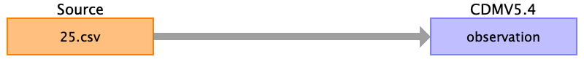

Table name: person

Table name: observation_period

Table name: visit_occurrence

Table name: visit_detail

Table name: condition_occurrence

Table name: drug_exposure

Table name: procedure_occurrence

Table name: device_exposure

Table name: measurement

Table name: observation

Reading from 25.csv

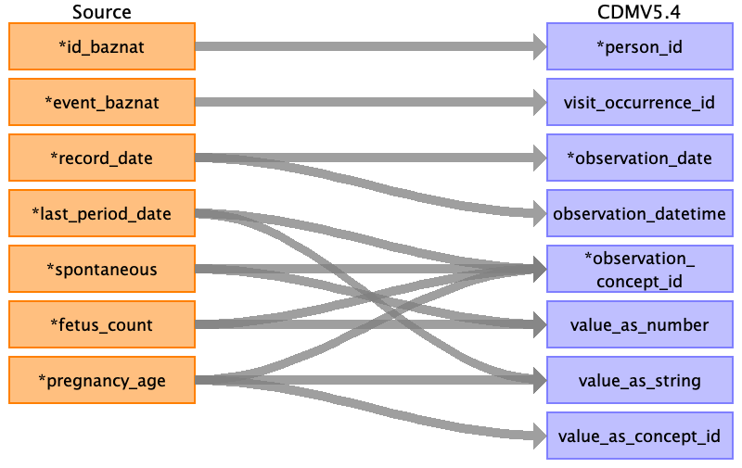

|  |  |  |  |
| --- | --- | --- | --- |
| Destination Field | Source Field | Logic | Comment |
| observation_id |  |  | ID run |
| person_id | ﻿id_baznat |  |  |
| visit_occurrence_id | event_baznat |  | Check if the value exists in the target table visit_occurrence , if not set as None |
| observation_date | record_date |  |  |
| observation_datetime | record_date |  |  |
| observation_concept_id | last_period_date  spontaneous  fetus_count  pregnancy_age |  | Set DATE_OF_LAST_NORMAL_PERIOD = 4088445  Set SPONTANEOUS = 4196694  Set FETUS = 40567571  1. value as string set Pregnancy_Age : 444135009  2. value as concept id ( by the number of week ) set PREGNANCY_AGE_BY_WEEK = 366323009 |
| observation_type_concept_id |  |  | EHR_CONCEPT_ID = 32817 |
| value_as_number | spontaneous  fetus_count |  | Value from source table. |
| value_as_string | last_period_date  pregnancy_age |  | Value from source table. |
| value_as_concept_id | pregnancy_age |  | be number of the week set the concept id :  TWENTY = 23464008  TWENTY_ONE = 41438001  TWENTY_TWO = 65035007  TWENTY_THREE = 86883006  TWENTY_FOUR = 313179009  TWENTY_FIVE = 72544005  TWENTY_SEX = 48688005  TWENTY_SEVEN = 46906003  TWENTY_EIGHT = 90797000  TWENTY_NINE = 45139008  THIRTY = 71355009  THIRTY_ONE = 64920003  THIRTY_TWO = 7707000  THIRTY_THREE = 78395001  THIRTY_FOUR = 13763000  THIRTY_FIVE = 84132007  THIRTY_SEX = 57907009  THIRTY_SEVEN = 43697006  THIRTY_EIGHT = 13798002  THIRTY_NINE = 80487005  FORTY = 46230007  FORTY_ONE = 63503002  FORTY_TWO = 36428009  FORTY_THREE = 90968009  FORTY_FOUR = 90968009  Not use in this field. |
| qualifier_concept_id |  |  | Not use in this field. |
| unit_concept_id |  |  | Not use in this field. |
| provider_id |  |  | Not use in this field. |
| visit_detail_id |  |  | According to visit_occuerrence id and time. |
| observation_source_value |  |  | Not use in this field. |
| observation_source_concept_id |  |  | Not use in this field. |
| unit_source_value |  |  | Not use in this field. |
| qualifier_source_value |  |  | Not use in this field. |
| value_source_value |  |  | Not use in this field. |
| observation_event_id |  |  | Not use in this field. |
| obs_event_field_concept_id |  |  | Not use in this field. |

Table name: death

Table name: note

Table name: note_nlp

Table name: specimen

Table name: fact_relationship

Table name: location

Table name: care_site

Table name: provider

Table name: payer_plan_period

Table name: cost

Table name: drug_era

Table name: dose_era

Table name: condition_era

Table name: episode

Table name: episode_event

Table name: metadata

Table name: cdm_source

Table name: cohort

Table name: cohort_definition

Appendix: source tables

Table: 24.csv

|  |  |  |  |
| --- | --- | --- | --- |
| Field | Type | Most freq. value | Comment |

Table: 25.csv

|  |  |  |  |
| --- | --- | --- | --- |
| Field | Type | Most freq. value | Comment |
| ﻿id_baznat | INT |  |  |
| event_baznat | INT |  |  |
| record_date | INT |  |  |
| unit | INT |  |  |
| last_period_date | INT |  |  |
| spontaneous | INT |  |  |
| fetus_count | INT |  |  |
| pregnancy_age | INT |  |  |